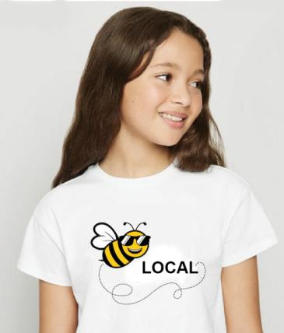
Bee Local

The Be Local is a project of the Butterflies & Bees Campaign, which strives to engage children in outdoor exploration and discovery to protect pollinators.
The program collaborates between retail garden stores, garden clubs, and local Rotary Clubs. An organizing meeting is scheduled for 3:00 February 23. The login is https://zoom.us/j/316745060
Sponsored by Healdsburg Pollinators https://www.facebook.com/groups/healdsburgpollinators

Concept:
Families and kids want to be more active and be outside. They also want to be safe and do something meaningful. Gardening and exploring nature are perfect ways to heal the pain and sacrifice of COVID confinement.
Action:
The Healdsburg Rotary Sunrise Club, known as the Jesters, has a tradition of focusing on youth and education efforts. This February, the Jesters decided to give away native wildflower seeds and received an overwhelming response. Clearly, we hit a nerve, not just from Healdsburg but also from all over the county. In just three weeks, a Facebook website was up and running. The attendance and enthusiasm at the launch event was very supportive of meeting the need.
Project Details
The task of engaging kids rests on the Bee Friendly Gardens initiative and the Bee Local Awards Club. Members pick up Bee Local Club recommended supplies at member stores. Garden Clubs provide support to Bee Local Club Members. The Facebook page Healdsburg Pollinators hosts a Protect Butterflies & Bees Group that provided support for the Bee Local Awards Club. Other Rotary Clubs are encouraged to use this as a prototype for creating a local support network. The high school Interact Clubs, sponsored by Rotary Clubs, will participate in the program with such projects as packing seeds and supporting Bee Local games for kids.
Date | Event - Subject | Coordinator | Notes
Feb 24  Zoom | Stakeholders Meeting  Introduce B&B Rewards | Jay | Room: Determine if needed
Feb 26 | Seed packing starts | Andy, Sunrise Club,  Interact
March 2  Zoom | Planning – Bee Events and programs | Andy, Jay | Rooms: Honey bees, wild bees and other pollinators
March 5 | Seed give away starts | Campaign Team, Sunrise Club
March 9  Zoom | Planning - B Friendly Garden, B&B Awards | Garden Team
March 16  Zoom | Kid’s Activities Planning | Education Team AVS, Greta, Jay | Rooms: Maker projects, Exploring game
March 23  Zoom | Kid’s Activities development started and launch prep | Education Team
March 24 | Kids Activities starts | Education Team, Jay
April 2  Zoom | Planning for Garden Design  Bee Friendly Gardens | Garden Team & Local Garden Clubs | Rooms: Beginner, Advanced

Schedule of Public and Organizational Zoom Meetings
Based on attendee feedback from previous meetings, sessions will be 45 minutes. Watch the video of our last meeting here: https://youtu.be/AqrZYfFn0ug. Break-out rooms are provided so participants can chat on specific aspects of the meeting subject.

Seeds for Pollinator Patches
Locally sourced wildflower seeds have been selected for summer and fall blooms. These plants provide nectar, pollen, food, and breeding locations for essential pollinating insects. Seed Packets are free, and no purchase is required. Store Displays illustrate recommended soil amendments and irrigation systems for in-store purchase. Additionally, information on vegetable gardens that support pollinators is provided.
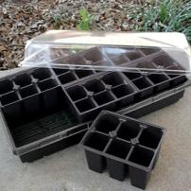
Sprouts
Because the best time to plant wildflowers is fall, these seeds will benefit from germination seed-starting systems. Milkweed for Monarchs and Pipevine for Swallowtails also benefit from this approach. Bee Local Club Members purchase supplies from Bee Local Stores. The BB campaign will provide instructions and support.

Explorers
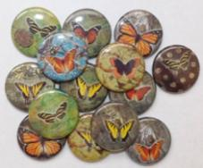
The first Bee Local Explorers program is a discovery game loosely patterned on Geocaching. Twelve caches are hidden around the community. Each cache contains a logbook and pencil to record visitors. They also contain a sticker of one type of butterfly. The first phase of the game is to use the Geocache App (free) to follow the clues to the sites and collect one stamp. They place these on a sheet to try to collect all 12. The next phase is to find out which plants the butterfly likes so they too can spot one. The children message other explorers to let them know the location so they can also make a “find.” The reward for a find is a pin for that butterfly.
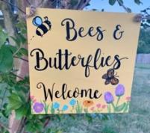
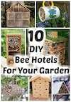
Makers
The Bee Local Makers create products that support the program, including bee hotels and watering stations, pollinator patch signs, and irrigation systems. This program is intended premaritally for scouts, 4H, and other kids' clubs.

Invitees:
Retail Garden Stores | Location | Representative
Friedman Home Improv | Santa Rosa, Petaluma, Sonoma, Ukiah | Rebecca Ehrlicher
Ace Hardware | Healdsburg, Windsor, Sebastopol
Prickett’s | Healdsburg, Santa Rosa
Harmony Farm Supply | Sebastopol
Cottage Gardens | Petaluma
Garden Clubs | Location | Representative
Healdsburg | Healdsburg | Melinda Wolcott, Pres
Windsor | Windsor | Cindy Fenton
Petaluma | Petaluma | Suzanne Clarke, Pres
Sebastopol | Sebastopol
Santa Rosa | Santa Rosa
DIGS | Digging Gardens in Sonoma
???
Rotary Clubs |  | Representative
Healdsburg, Sunrise |  | Nancy Palumbo, Pres
Windsor
Petaluma
Sebastopol
Santa Rosa |  | Kathy Flamson
Santa Rosa East |  | Katrina Zavalney
Rotary District 5130 | Environmental Sustainability Action | Yavuz Atila
 | Tiny Gardens | Andrew Barnett
Outreach - Networking |  | Representative
CMOSC | Children’s Museum of Sonoma County | Collette Michaud
Galora | Homegrown and made trading platform | Ryan Xavier
GoLocal Cooperative | Economic development marketing | Janeen Murray
Press Democrat |  | Ann Carranza
Sonoma County Gazette |  | Vesta Copestakes
Sonoma West |  | Rollie Atkinson
Argust Courier
Sonoma Index-Tribune
Daily Acts
Milo Baker Native Plants
iGrow Sonoma
Community Soil Foundation
Community Seed Exchange
Supervisors |  | Representative
Susan Gorin | 1st District
Chris Coursey | 3rd District
James Gore | 4th District | Jen Mendoza
Lynda Hopkins | 5th District

